**Assignment 8: Social Network Analysis**

**Tong Wei (TOW6) JinRong Liu (JIL181) FengXi Liu ( FEL34)**

1.

Below is the structure of the graph:

(1,5)

(2,1), (2,5), (2,6), (2,10)

(4,7), (4,8), (4,9)

(6,1), (6,2), (6,7) (7,3)

(11,2) (12,1), (12,10), (12,13) (13,3) (14,3) (15,3), (15,4), (15,9).

Then implement HITS algorithm, below is the source code on matlab:

function HITS(A,iter)

n=length(A);

pre_a=ones(1,n);

pre_a(:)=1/n;

pre_h=ones(1,n);

pre_h(:)=1/n;

[a, h]=computeHITS(A,pre_a,pre_h);

i=1;

while(i<=iter&&~(isConvergenceA(A,pre_a,a)&&isConvergenceH(A,pre_h,h)))

fprintf('%d:\n',i);

pre_a=a;

pre_h=h;

[a, h]=computeHITS(A,pre_a,pre_h);

a=round(a,3);

h=round(h,3);

fprintf('\tauthorithy score:\t%3.2f,%3.2f,%3.2f,%3.2f,%3.2f,%3.2f,%3.2f,%3.2f,%3.2f,%3.2f,%3.2f,% 3.2f,%3.2f,%3.2f,%3.2f:\n',a(1),a(2),a(3),...

a(4),a(5),a(6),a(7),a(8),a(9),a(10),a(11),a(12),a(13),a(14),a(15));

fprintf('\thubscore:\t\t%4.2f,%4.2f,%4.2f,%4.2f,%4.2f,%4.2f,%4.2f,%4.2f,%4.2f,%4.2f,%4.2f ,%4.2f,%4.2f,%4.2f,%4.2f:\n',h(1),h(2),h(3),...

h(4),h(5),h(6),h(7),h(8),h(9),h(10),h(11),h(12),h(13),h(14),h(15));

function [newa, newh]=computeHITS(A,a,h)

n=length(A);%number of nodes;

newa=a;

newh=h;

for i=1:n

suma=0;

sumh=0;

for j=1:n

if(A(i,j)==1)%i->j suma=suma+a(j);

end if(A(j,i)==1)%j->i

sumh=sumh+h(j);

end end

newa(i)=sumh;

newh(i)=suma;

end

newa=process(newa);

newh=process(newh);

end

function flag=isConvergenceA(A,v,pre_v)

if(v'==A'*A*pre_v')

flag=1;

else

flag=0;

end

end

function flag=isConvergenceH(A,v,pre_v)

if(v'==A*A'*pre_v')

flag=1;

else

flag=0;

end

end

function y=process(x)

MinValue=min(x);

MaxValue=max(x);

y=x/MaxValue;

end

And then, we can get the answer after running the following code:

A=zeros(15);

A(12,10)=1;A(12,1)=1; A(12,13)=1; A(14,3)=1;A(15,3)=1;A(15,4)=1;A(15,9)=1;A(13,3)=1;A(4,9)=1;A(4,8)=1;A(4,7)= 1;A(2,10)=1; A(2,1)=1;A(2,5)=1;A(2,6)=1;A(6,2)=1;A(6,7)=1;A(6,1)=1;A(5,10)=1;A(5,8)=1;A(1,5)=1;

HITS(A,1000)

**above figure is to assign that the distance of all links are 1.**

Below is the result of HITS algorithm:

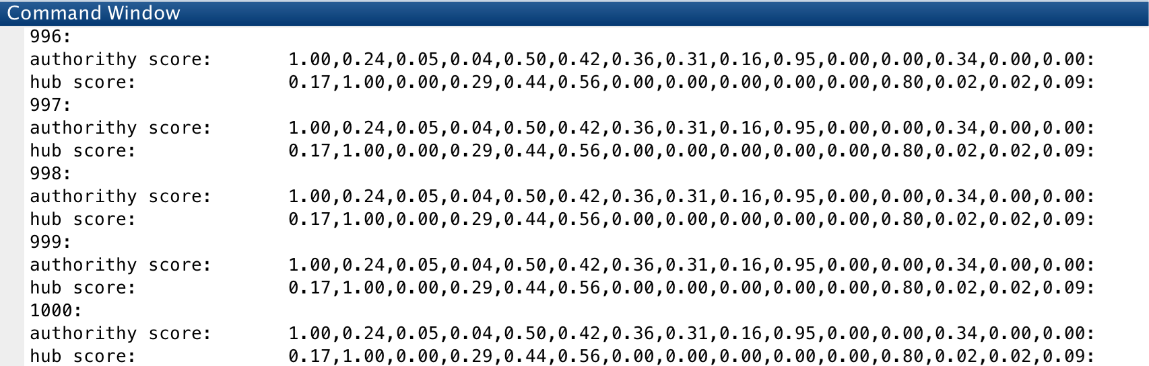

The authority scores and hub scores: 

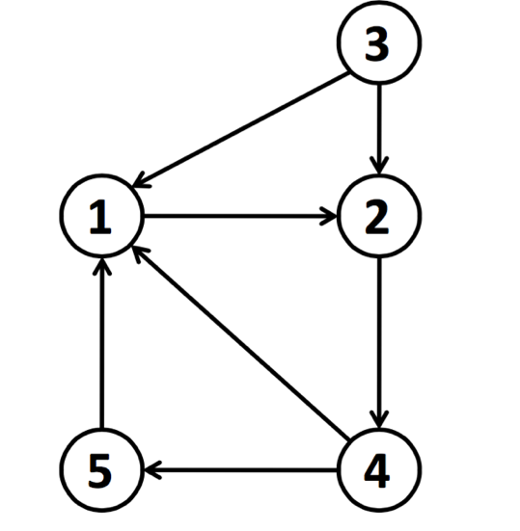**2. For this question, we should figure out which node belongs to authority or hub or both. If the node belongs to both, it is not consistent with the notion of authority and hub.**

For graph 1:

Node 1: both authority and hub;

Node 2: both authority and hub;

Node 3: only hub;

Node 4: both authority and hub;

Node 5: both authority and hub;

So, it is obvious that only node 3 is the hub,

because it is consistent with the notions of Hubs and Authorities.

Graph 1

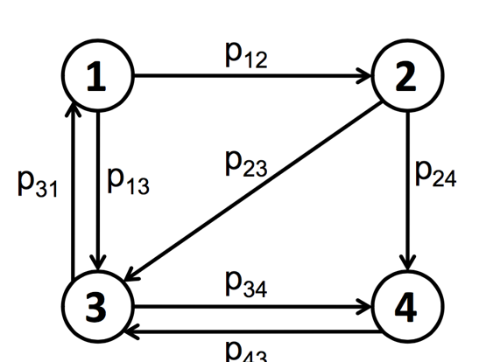

All nodes are authorities and hubs,

they are all not consistent with the

notions of Hubs and Authorities.

Graph 2